Spring 老张

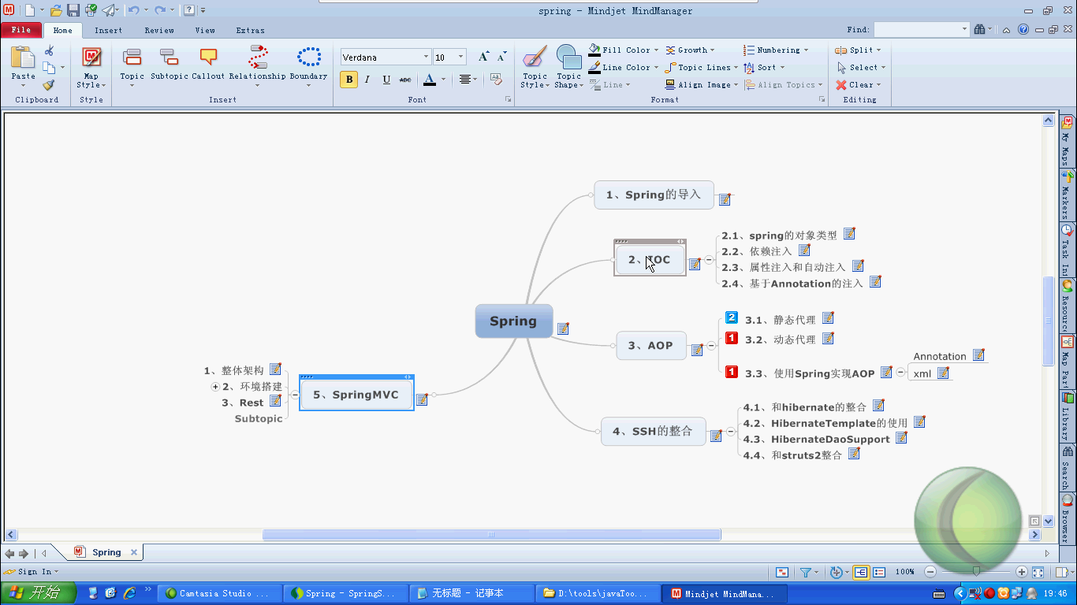

环境搭建

- 导入jar包
- 导入配置文件

案例

User对象

package com.yellowcong.spring.model;

public class User {
private int id;
private String username;
private String password;

public User() {
super();
// TODO Auto-generated constructor stub
System.out.println("实例化");
}
public int getId() {
return id;
}
public void setId(int id) {
this.id = id;
}
public String getUsername() {
return username;
}
public void setUsername(String username) {
this.username = username;
}
public String getPassword() {
return password;
}
public void setPassword(String password) {
this.password = password;
}
}

ApplicationContext.xml
<?xml version="1.0" encoding="UTF-8"?>
<beans xmlns="http://www.springframework.org/schema/beans"
xmlns:xsi="http://www.w3.org/2001/XMLSchema-instance"
xsi:schemaLocation="http://www.springframework.org/schema/beans
http://www.springframework.org/schema/beans/spring-beans-2.0.xsd">

<bean id="user" class="com.yellowcong.spring.model.User">
<property name="id" value="1"/>
<property name="username" value="yellowcong"/>
<property name="password" value="yellowcong"/>
</bean>
</beans>

三种获取方法
ClassPathXMLApplicationContext 快捷 高效， 废资源
FileSystemXMLApplicationContext 平台限制
BeanFactory 慢 节约资源

package junit.test;

import org.junit.Test;
import org.springframework.beans.factory.BeanFactory;
import org.springframework.beans.factory.xml.XmlBeanFactory;
import org.springframework.context.ApplicationContext;
import org.springframework.context.support.ClassPathXmlApplicationContext;
import org.springframework.context.support.FileSystemXmlApplicationContext;
import org.springframework.core.io.ClassPathResource;

import com.yellowcong.spring.model.User;

public class UserTest {

//这种方法用得最多
//通过ClassPathApplication 来获取对象
@Test
public void testGetUser(){
//使用ApplicationContext 来实例化对象的时候，会将对象实例化一份
ApplicationContext context = new ClassPathXmlApplicationContext("ApplicationConfig.xml");
User user = (User)context.getBean("user");
System.out.println(user.getUsername());

}

//通过BeanFactory 来实例化对象
@Test
public void getByFactory(){
//实例化容器， 但是不会直接获取对象， 这个适用于小内存的移动设备
BeanFactory factory = new XmlBeanFactory(new ClassPathResource("ApplicationConfig.xml"));
//当我们调用的时候就会实例化对象
User user = (User)factory.getBean("user");
System.out.println(user.getUsername());
}

//通过FileSystemXmlApplicationContext获取
@Test
public void getByFilePath(){
String url = User.class.getClassLoader().getResource("ApplicationConfig.xml").toString();
ApplicationContext context = new FileSystemXmlApplicationContext(url);

User user = (User)context.getBean("user");
System.out.println(user.getUsername());
}
}

SCOPE
其中类型 主要几个， 默认的是
<?xml version="1.0" encoding="UTF-8"?>
<beans xmlns="http://www.springframework.org/schema/beans"
xmlns:xsi="http://www.w3.org/2001/XMLSchema-instance"
xsi:schemaLocation="http://www.springframework.org/schema/beans
http://www.springframework.org/schema/beans/spring-beans-2.0.xsd">
<!--通过配置singleton 可以设定为单例， 不过默认为 singleton
scope=prototype 可以设定为原型， 创建出不同的实例
-->
<bean id="user" class="com.yellowcong.spring.model.User" scope="singleton">
<property name="id" value="1"/>
<property name="username" value="yellowcong"/>
<property name="password" value="yellowcong"/>
</bean>
</beans>

@Test
public void getByFilePath(){
//通过设定scope=prototype 这样就不是原型了
//默认情况都是一个 单利singleton
ApplicationContext context = new ClassPathXmlApplicationContext("ApplicationConfig.xml");
User user = (User)context.getBean("user");

User user2 = (User)context.getBean("user");
System.out.println(user==user2?"同一个数据":"不是同一个");
}

IOC 依赖注入

对于状态变的数据，我们需要设定scope 设定原型。就比如我们设定一些数据的时候，比如UserAction 来设定数据的时候，需要设定为原型

案例
User --UserDao --UserDaoImpl
--UserService -- UserServiceImpl
--UserAction

User
package com.yellowcong.spring.model;

public class User {
private int id;
private String username;
private String password;

public User() {
super();
// TODO Auto-generated constructor stub
System.out.println("实例化");
}

public User(int id, String username, String password) {
super();
this.id = id;
this.username = username;
this.password = password;
}

public int getId() {
return id;
}
public void setId(int id) {
this.id = id;
}
public String getUsername() {
return username;
}
public void setUsername(String username) {
this.username = username;
}
public String getPassword() {
return password;
}
public void setPassword(String password) {
this.password = password;
}
}

UserDao
package com.yellowcong.dao;

import com.yellowcong.spring.model.User;

public interface UserDao {

//定义UserDao 中的方法
public User loadUser(int id);
public void deleteUser(int id);
public void addUser(User user);
}

UserDaoImp
package com.yellowcong.dao.impl;

import com.yellowcong.dao.UserDao;
import com.yellowcong.spring.model.User;

public class UserDaoImpl implements UserDao {

@Override
public void addUser(User user) {
// TODO Auto-generated method stub
System.out.println("添加了user:"+user.getUsername());
}

@Override
public void deleteUser(int id) {
// TODO Auto-generated method stub
System.out.println("删除了User，id="+id);
}

@Override
public User loadUser(int id) {
// TODO Auto-generated method stub
System.out.println("加载User"+id);
return null;
}

}

UserService
package com.yellowcong.service;

import com.yellowcong.spring.model.User;

public interface UserService {
public User load(int id);
public void deleteUser(int id);
public void addUser(User user);
}

UserServiceImpl
package com.yellowcong.service.impl;

import com.yellowcong.dao.UserDao;
import com.yellowcong.service.UserService;
import com.yellowcong.spring.model.User;

public class UserServiceImpl implements UserService{
UserDao userDao ;

//注入UserDao
public void setUserDao(UserDao userDao) {
this.userDao = userDao;
}

@Override
public void addUser(User user) {
// TODO Auto-generated method stub
userDao.addUser(user);
}

@Override
public void deleteUser(int id) {
// TODO Auto-generated method stub
userDao.deleteUser(id);
}

@Override
public User load(int id) {
// TODO Auto-generated method stub
return userDao.loadUser(id);
}

}

package com.yellowcong.action;

import com.yellowcong.service.UserService;
import com.yellowcong.spring.model.User;

public class UserAction {
private User user;
private UserService userService;
private int id;

public User getUser() {
return user;
}

public void setUser(User user) {
this.user = user;
}

public int getId() {
return id;
}

public void setId(int id) {
this.id = id;
}

public void setUserService(UserService userService) {
this.userService = userService;
}

public void add(){
userService.addUser(user);
}

public void delete(){
userService.deleteUser(id);
}

public void load(){
userService.load(id);
}
}

测试类
package junit.test;

import org.junit.Test;
import org.springframework.context.ApplicationContext;
import org.springframework.context.support.ClassPathXmlApplicationContext;

import com.yellowcong.action.UserAction;
import com.yellowcong.spring.model.User;

public class TestUserIOC {

private ApplicationContext context = new ClassPathXmlApplicationContext("ApplicationConfig.xml");
//注入
@Test
public void test(){
UserAction action = (UserAction)context.getBean("userActoin");
User user = new User(1,"yellowcong","xiaophai");
action.setUser(user); // 其中这个就是我们Struts 中注入数据

action.add();
}

}

配置文件
<?xml version="1.0" encoding="UTF-8"?>
<beans xmlns="http://www.springframework.org/schema/beans"
xmlns:xsi="http://www.w3.org/2001/XMLSchema-instance"
xsi:schemaLocation="http://www.springframework.org/schema/beans
http://www.springframework.org/schema/beans/spring-beans-2.0.xsd">

<bean id="user" class="com.yellowcong.spring.model.User" scope="singleton">
</bean>

<bean id="userDao" class="com.yellowcong.dao.impl.UserDaoImpl"></bean>
<!-- 注入数据 -->
<bean id="userService" class="com.yellowcong.service.impl.UserServiceImpl">
<property name="userDao" ref="userDao"/>
</bean>
<bean id="userActoin" class="com.yellowcong.action.UserAction" scope="prototype">
<property name="userService" ref="userService"></property>
</bean>
</beans>

自动注入 属性注入

通过构造函数注入
<!-- 使用构造函数注入, 这种方法不常用，一般都是使用set方法注入 -->
<bean id="userActoin" class="com.yellowcong.action.UserAction" scope="prototype">
<constructor-arg ref="userService"/>
</bean>

添加构造方法
package com.yellowcong.action;

import com.yellowcong.service.UserService;
import com.yellowcong.spring.model.User;

public class UserAction {
private User user;
private UserService userService;
private int id;

public UserAction(UserService userService) {
super();
this.userService = userService;
}

public User getUser() {
return user;
}

public void setUser(User user) {
this.user = user;
}

public int getId() {
return id;
}

public void setId(int id) {
this.id = id;
}

public void add(){
userService.addUser(user);
}

public void delete(){
userService.deleteUser(id);
}

public void load(){
userService.load(id);
}
}

自动注入
其中自动注入的可以再 schemal中声明
其中自动注入是一般不用的
<!-- autowire 自动注入 default 是默认配置
byName 通过名称注入 根据Set方法来查找数据，查找不到 抛出异常
byType 通过类型注入 如果有多个类的时候，会抛出异常
-->
<bean id="userService" class="com.yellowcong.service.impl.UserServiceImpl" autowire="byName">
</bean>

全局设定ByName 自动注入
<?xml version="1.0" encoding="UTF-8"?>
<beans xmlns="http://www.springframework.org/schema/beans"
xmlns:xsi="http://www.w3.org/2001/XMLSchema-instance"
xsi:schemaLocation="http://www.springframework.org/schema/beans
http://www.springframework.org/schema/beans/spring-beans-2.0.xsd" default-autowire="byName">

注入集合数据

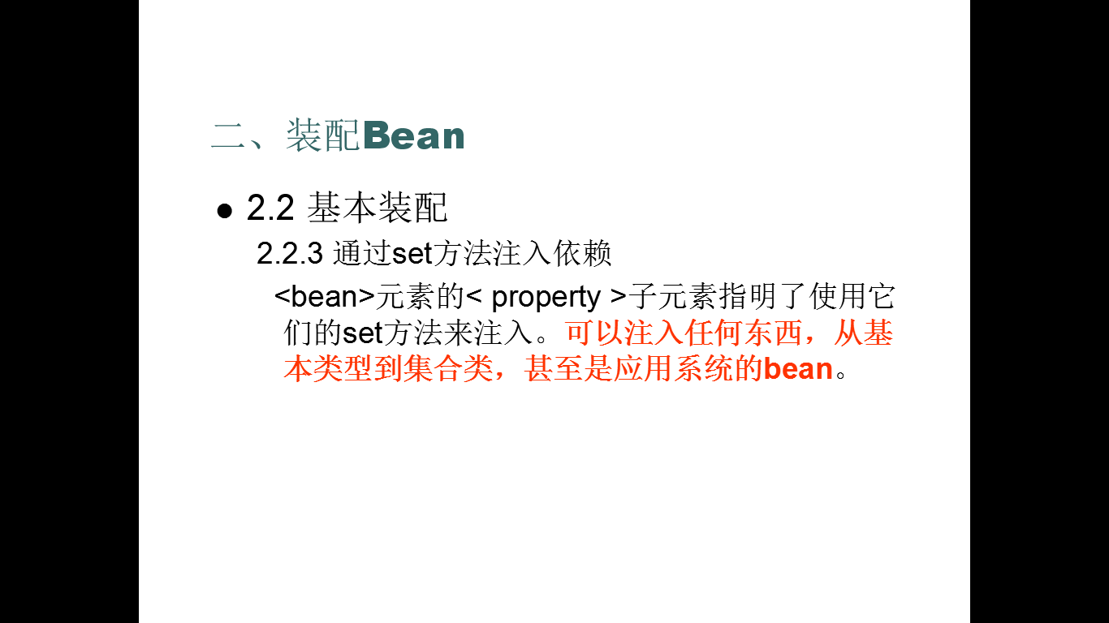
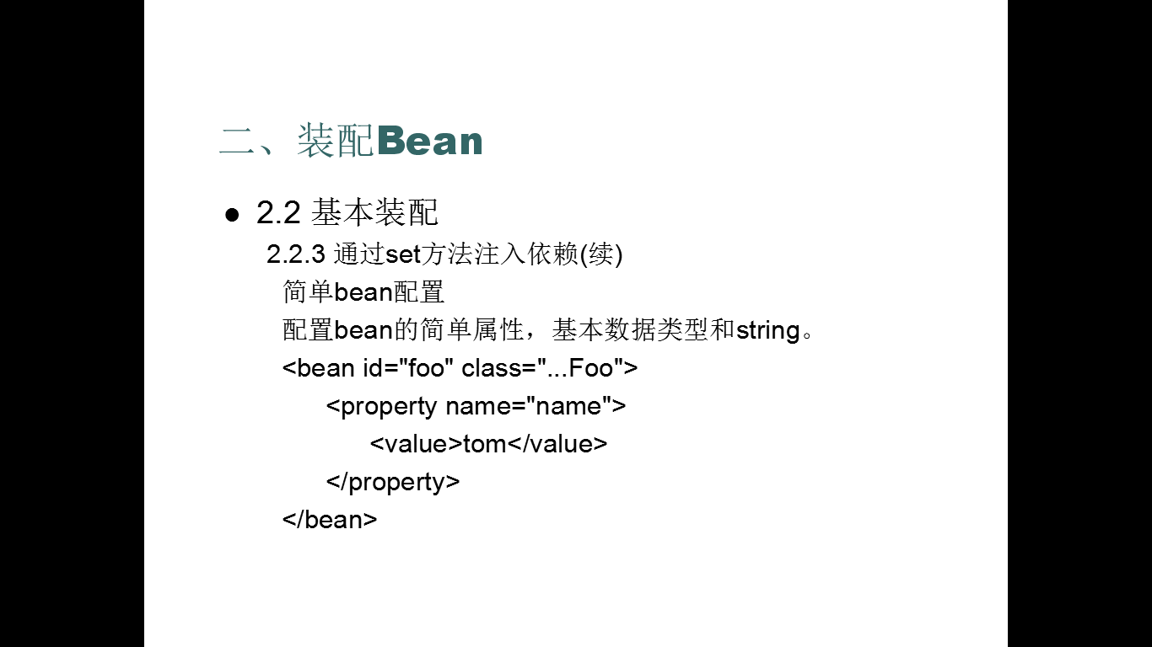

集合类型的装配

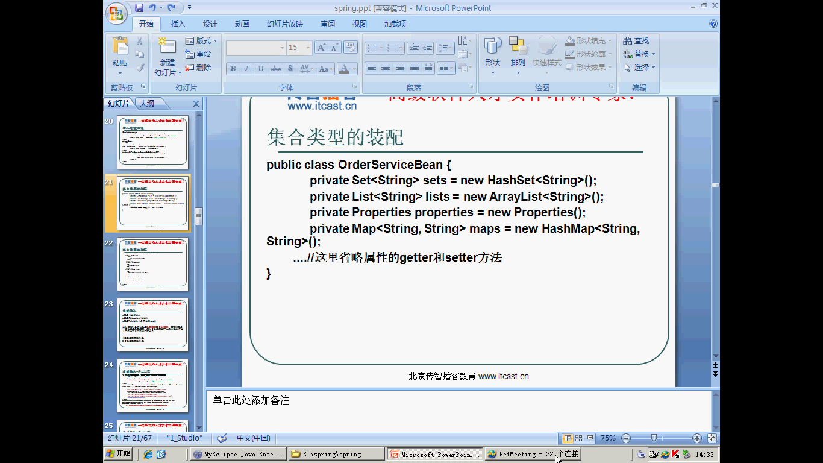

注入Set集合
<!-- 注入Set集合 -->
<bean id="insertSet" class="com.yellowcong.spring.day01.SpringSetBean">
<property name="haseset">
<set>
<value>第一个数据</value>
<value>第二个数据</value>
<value>第三个数据</value>
<value>第四个数据</value>
</set>
</property>
</bean>

注入List集合
其中通过List 也可以注入数组中的数据
<property name="arrayList">
<list>
<value>List集合</value>
<value>List集合</value>
<value>List集合</value>
<value>List集合</value>
<value>List集合</value>
</list>
</property>

注入Properties数据
<property name="properties">
<props>
<prop key="key1">values1</prop>
<prop key="key2">values2</prop>
<prop key="key3">values3</prop>
</props>
</property>

注入Map集合
<property name="hashMap">
<map>
<entry key="key1" value="yellow1"/>
<entry key="key2" value="yellow2"/>
<entry key="key3" value="yellow3"/>
<entry key="key4" value="yellow4"/>
</map>
</property>

案例
package com.yellowcong.spring.model;

import java.util.List;
import java.util.Map;
import java.util.Properties;
import java.util.Set;

public class Parameters {

private Properties properties;
private Set<String> names;
private List<String> nicknames;
private Map<String,String> entrys;
public Properties getProperties() {
return properties;
}
public void setProperties(Properties properties) {
this.properties = properties;
}
public Set<String> getNames() {
return names;
}
public void setNames(Set<String> names) {
this.names = names;
}
public List<String> getNicknames() {
return nicknames;
}
public void setNicknames(List<String> nicknames) {
this.nicknames = nicknames;
}
public Map<String, String> getEntrys() {
return entrys;
}
public void setEntrys(Map<String, String> entrys) {
this.entrys = entrys;
}
}

注入数据
<!-- 集合中注入数据 -->
<bean id="patameter" class="com.yellowcong.spring.model.Parameters" scope="prototype">
<property name="names">
<set>
<value>yellow</value>
<value>yellow2</value>
<value>yellow3</value>
<value>yellow4</value>
</set>
</property>

<property name="nicknames">
<list>
<value>cong</value>
<value>cong2</value>
<value>cong3</value>
<value>cong4</value>
</list>
</property>

<property name="entrys">
<map>
<entry key="name" value="yellowcong"/>
<entry key="name2" value="yellowcong2"/>
<entry key="name3" value="yellowcong3"/>
<entry key="name4" value="yellowcong4"/>
</map>
</property>

<property name="properties">
<props>
<prop key="url">value1</prop>
<prop key="url2">value2</prop>
<prop key="url3">value3</prop>
<prop key="url4">value4</prop>
</props>
</property>
</bean>

测试
package junit.test;

import java.util.List;
import java.util.Map;
import java.util.Properties;
import java.util.Set;
import java.util.Map.Entry;

import org.junit.Test;
import org.springframework.context.ApplicationContext;
import org.springframework.context.support.ClassPathXmlApplicationContext;

import com.yellowcong.spring.model.Parameters;

public class TestParameters {
private ApplicationContext context = new ClassPathXmlApplicationContext("ApplicationConfig.xml");

@Test
public void testGetValues(){
Parameters par = (Parameters) context.getBean("patameter");
Properties pro = par.getProperties();

//获取数据Properties
for(Entry<Object,Object> p :pro.entrySet()){
System.out.println(p.getKey()+"___"+p.getValue());
}
//获取Set
Set<String> names = par.getNames();
for(String name :names){
System.out.println(name);
}

//获取List
List<String> nicknames = par.getNicknames();
for(String nickname :nicknames){
System.out.println(nickname);
}

//获取Map
Map<String,String> entrys = par.getEntrys();
for(Entry<String,String> entry :entrys.entrySet()){
System.out.println(entry.getKey()+"__"+entry.getValue());
}

}
}

基于Annotation的注入
对于我呢的所有项目，对于小的或者中型项目我们可以使用Annotation 配置
对于大型项目，我们需要使用XML 来实现， 同我们的Hibernate 的Annotation的配置

使用我们的注解来实现注入

其中我们需要导入context 的配置

配置打开Annotation 配置
<?xml version="1.0" encoding="UTF-8"?>
<beans xmlns="http://www.springframework.org/schema/beans"
xmlns:xsi="http://www.w3.org/2001/XMLSchema-instance"
xmlns:context="http://www.springframework.org/schema/context"
xsi:schemaLocation="http://www.springframework.org/schema/beans
http://www.springframework.org/schema/beans/spring-beans-2.0.xsd
http://www.springframework.org/schema/context
http://www.springframework.org/schema/context/spring-context-2.5.xsd">

<!-- 其中首先要配置我们的Annotation中的schema 文件 -->
<!-- 打开Annotation -->
<context:annotation-config />
<!--设定在哪些包中查找数据-->
<context:component-scan base-package="com.yellowcong"/>
</beans>

注入的方法主要有
@Component 这个是用来注入Bean的， 所有的都可以用这个操作
其中这个又分成了几个，不同的业务层，使用不同的方法
@Service Service 层
@Controller 控制层Action
@Repository DAO层

注入的两种方式：
@Resource 这个是通过名称来注入数据
@Autowired 这个是通过类型来注入 ，不过 一般不用这个

@Scope 设定 是否原型

案例
DAO

package com.yellowcong.dao.impl;

import org.springframework.stereotype.Component;
import org.springframework.stereotype.Repository;

import com.yellowcong.dao.UserDao;
import com.yellowcong.spring.model.User;
//这个就意味着我们导入了一个Bean
//@Component("userDao")

//Repository 表示是我们的DAO层
@Repository("userDao")
public class UserDaoImpl implements UserDao {

@Override
public void addUser(User user) {
// TODO Auto-generated method stub
System.out.println("添加了user:"+user.getUsername());
}

@Override
public void deleteUser(int id) {
// TODO Auto-generated method stub
System.out.println("删除了User，id="+id);
}

@Override
public User loadUser(int id) {
// TODO Auto-generated method stub
System.out.println("加载User"+id);
return null;
}

}

Service
package com.yellowcong.service.impl;

import javax.annotation.Resource;
import org.springframework.stereotype.Component;
import org.springframework.stereotype.Service;

import com.yellowcong.dao.UserDao;
import com.yellowcong.service.UserService;
import com.yellowcong.spring.model.User;
//@Component("userService")
@Service("userService")
public class UserServiceImpl implements UserService{
UserDao userDao ;

//注入UserDao
@Resource
public void setUserDao(UserDao userDao) {
this.userDao = userDao;
}

@Override
public void addUser(User user) {
// TODO Auto-generated method stub
userDao.addUser(user);
}

@Override
public void deleteUser(int id) {
// TODO Auto-generated method stub
userDao.deleteUser(id);
}

@Override
public User load(int id) {
// TODO Auto-generated method stub
return userDao.loadUser(id);
}

}

Action
package com.yellowcong.action;

import javax.annotation.Resource;

import org.springframework.beans.factory.annotation.Autowired;
import org.springframework.context.annotation.Scope;
import org.springframework.stereotype.Component;
import org.springframework.stereotype.Controller;

import com.yellowcong.service.UserService;
import com.yellowcong.spring.model.User;

//
//@Component("userAction")
//Controller 表示的是控制层

@Controller("userAction")
@Scope("prototype")
public class UserAction {
private User user;
private UserService userService;
private int id;

@Resource
public void setUserService(UserService userService) {
this.userService = userService;
}

public User getUser() {
return user;
}

public void setUser(User user) {
this.user = user;
}

public int getId() {
return id;
}

public void setId(int id) {
this.id = id;
}

public void add(){
userService.addUser(user);
}

public void delete(){
userService.deleteUser(id);
}

public void load(){
userService.load(id);
}
}

测试类
package junit.test;

import org.junit.Test;

import org.springframework.context.ApplicationContext;
import org.springframework.context.support.ClassPathXmlApplicationContext;

import com.yellowcong.action.UserAction;
import com.yellowcong.spring.model.User;

public class TestUserIOC {

private ApplicationContext context = new ClassPathXmlApplicationContext("ApplicationConfig.xml");
//注入
@Test
public void test(){
UserAction action = (UserAction)context.getBean("userAction");
User user = new User(1,"yellowcong","xiaophai");
action.setUser(user); // 其中这个就是我们Struts 中注入数据

action.add();
}

}

AOP面向切面编程

静态代理
我们在给指定的类添加方法，但是我们不可以修改原来的代码，这时候我们就需要静态代理对象了

案例
给我们以前定义的UserDao 中添加日志代理

建立代理对象，需要实现接口，因为Service 中的对象使用的就是接口
package com.yellowcong.proxy;

import javax.annotation.Resource;

import org.apache.log4j.Logger;
import org.springframework.stereotype.Repository;

import com.yellowcong.dao.UserDao;
import com.yellowcong.dao.impl.UserDaoImpl;
import com.yellowcong.spring.model.User;

@Repository("userDaoProxy")
public class UserDaoProxy implements UserDao {
public static Logger logger = Logger.getLogger(UserDao.class);
UserDaoImpl userDaoImpl;

@Resource(name="userDao")
public void setUserDaoImpl(UserDaoImpl userDaoImpl) {
this.userDaoImpl = userDaoImpl;
}

@Override
public void addUser(User user) {
// TODO Auto-generated method stub
logger.info("添加了用户");
userDaoImpl.addUser(user);
}

@Override
public void deleteUser(int id) {
// TODO Auto-generated method stub
logger.info("删除了用户");
userDaoImpl.deleteUser(id);
}

@Override
public User loadUser(int id) {
// TODO Auto-generated method stub
logger.info("加载用户");
return userDaoImpl.loadUser(id);
}

}

修改我们的UserServiceImp

package com.yellowcong.service.impl;

import javax.annotation.Resource;
import org.springframework.stereotype.Component;
import org.springframework.stereotype.Service;

import com.yellowcong.dao.UserDao;
import com.yellowcong.service.UserService;
import com.yellowcong.spring.model.User;
//@Component("userService")
@Service("userService")
public class UserServiceImpl implements UserService{
UserDao userDao ; //其中这个是接口

//注入UserDao
@Resource(name="userDaoProxy") //修改成注入我们的代理对象
public void setUserDao(UserDao userDao) {
this.userDao = userDao;
}

@Override
public void addUser(User user) {
// TODO Auto-generated method stub
userDao.addUser(user);
}

@Override
public void deleteUser(int id) {
// TODO Auto-generated method stub
userDao.deleteUser(id);
}

@Override
public User load(int id) {
// TODO Auto-generated method stub
return userDao.loadUser(id);
}

}

动态代理
当我们有多个需要同样的操作的时候，如果我们都是这样一遍一遍的添加对象，比较的麻烦，所以我们需要动态代理来解决这个问题

其中动态代理需要是吸纳InvocationHandle这个接口

案例
给我们的UserDao 创建动态代理

package com.yellowcong.proxy;

import java.lang.reflect.InvocationHandler;
import java.lang.reflect.Method;
import java.lang.reflect.Proxy;

import org.apache.log4j.Logger;

import com.yellowcong.spring.model.User;

public class UserDaoDynamicProxy implements InvocationHandler {
private Object target;
//私有化构造方法
private UserDaoDynamicProxy(){}

//其中我们传入的是 本身对象 获取的是代理对象
public static Object getInstance(Object obj){
UserDaoDynamicProxy proxy = new UserDaoDynamicProxy();
proxy.target = obj; //给我们的传入的对象赋值
//获取我们的代理对象
Object result = Proxy.newProxyInstance(
obj.getClass().getClassLoader(), //获取类加载器
obj.getClass().getInterfaces(), //获取接口
proxy);
//Proxy 是实现了InvocationHandler的代理对象

return result;
}

@Override
public Object invoke(Object proxy, Method method, Object[] args)
throws Throwable {
// TODO Auto-generated method stub
Logger logger = Logger.getLogger(User.class);
//然后我们在这个地方就可以对对象进行任何操作了
if(method.getName().equals("loadUser")){
logger.info("执行了加载");
}
if(method.getName().equals("addUser")){
logger.info("添加了数据");
}
if(method.getName().equals("deleteUser")){
logger.info("删除了数据");
}
Object obj = method.invoke(target, args);
return obj;
}

}

配置代理对象
<bean name="dynamicProxy" class="com.yellowcong.proxy.UserDaoDynamicProxy" factory-method="getInstance">
<constructor-arg ref="userDao"/>
</bean>

调用代理对象
package com.yellowcong.service.impl;

import javax.annotation.Resource;
import org.springframework.stereotype.Service;

import com.yellowcong.dao.UserDao;
import com.yellowcong.service.UserService;
import com.yellowcong.spring.model.User;
//@Component("userService")
@Service("userService")
public class UserServiceImpl implements UserService{
UserDao userDao ; //其中这个是接口

//注入UserDao
//通过动态代理来注入我们的对象
@Resource(name="dynamicProxy")
public void setUserDao(UserDao userDao) {
this.userDao = userDao;
}

@Override
public void addUser(User user) {
// TODO Auto-generated method stub
userDao.addUser(user);
}

@Override
public void deleteUser(int id) {
// TODO Auto-generated method stub
userDao.deleteUser(id);
}

@Override
public User load(int id) {
// TODO Auto-generated method stub
return userDao.loadUser(id);
}

}

AOP基于Annotation
搭建环境
1.导入我们需要的Schema文件 aop
2.设定自动代理
其中我们需要设定自动代理，这个对于我们的设定中是必须的。

其中主要的Annotation
@Aspect //切面 通过这个注解来申明我们的 切面

//这几个为我们的切面
@Befor JoinPoint 在之前植入
@After JoinPoint 在之后植入
@Around 中的 类ProceedingJoinPoint 在环绕中植入

配置 织入我们的代理的配置
@Before("execution(* com.yellowcong.dao.impl.*.add*(..))")

简单实例
配置文件
<?xml version="1.0" encoding="UTF-8"?>
<beans xmlns="http://www.springframework.org/schema/beans"
xmlns:xsi="http://www.w3.org/2001/XMLSchema-instance"
xmlns:aop="http://www.springframework.org/schema/aop"
xmlns:context="http://www.springframework.org/schema/context"
xsi:schemaLocation="http://www.springframework.org/schema/beans
http://www.springframework.org/schema/beans/spring-beans-2.0.xsd
http://www.springframework.org/schema/context
http://www.springframework.org/schema/context/spring-context-2.5.xsd
http://www.springframework.org/schema/aop
http://www.springframework.org/schema/aop/spring-aop-2.0.xsd">

<!-- 其中首先要配置我们的Annotation中的schema 文件 -->
<!-- 打开Annotation -->
<context:annotation-config />
<!--设定在哪些包中查找数据-
->
<context:component-scan base-package="com.yellowcong"/>

<!-- 设定自动代理 -->
<aop:aspectj-autoproxy/>
</beans>

我们的通知

package com.yellowcong.proxy;

import org.aspectj.lang.JoinPoint;
import org.aspectj.lang.ProceedingJoinPoint;
import org.aspectj.lang.annotation.After;
import org.aspectj.lang.annotation.Around;
import org.aspectj.lang.annotation.Aspect;
import org.aspectj.lang.annotation.Before;
import org.springframework.stereotype.Component;

@Component("myProxy")
@Aspect
// 声明这个是一个切面类
public class MyProxy {

/*
* 第一个* 表示的是所有返回值 第二个* 表示的是 com.yellowcong.dao.impl 中的所有类 第三个* 表示的是所有的addXx
* 方法 (..) 表示任意的参数
*
* 其中可以加入多个方法
*/
@Before("execution(* com.yellowcong.dao.impl.*.add*(..))"
+ "execution(* com.yellowcong.dao.impl.*.update*(..))"
+ "execution(* com.yellowcong.dao.impl.*.load*(..))")
public void logStart(JoinPoint jp) {
// 通过JoinPoint 获取执行的类和方法，
System.out.println("调用的类:\t" + jp.getTarget()); // 获取执行的类
System.out.println("调用的方法:\t" + jp.getSignature().getName()); // 获取执行的方法
System.out.println("开始记录所有的数据");
}

// 调用org.aspectj.lang.annotation.After; 这个After
@After("execution(* com.yellowcong.dao.impl.*.add*(..))"
+ "execution(* com.yellowcong.dao.impl.*.update*(..))"
+ "execution(* com.yellowcong.dao.impl.*.load*(..))")
public void logAfter() {
System.out.println("结束的方法");
}

// 环绕通知
@Around("execution(* com.yellowcong.dao.impl.*.add*(..))"
+ "execution(* com.yellowcong.dao.impl.*.update*(..))"
+ "execution(* com.yellowcong.dao.impl.*.load*(..))")
public void logAround(ProceedingJoinPoint pj) throws Throwable {
System.out.println("环绕通知调用前");
pj.proceed();//执行函数
System.out.println("环绕通知的调用后");
}
}

AOP基于XML

其中对于我们的Aspect 切面织入 ，所以我们在实践中，使用xml配置我们的AOP ,因为这个比较的简单

<?xml version="1.0" encoding="UTF-8"?>
<beans xmlns="http://www.springframework.org/schema/beans"
xmlns:xsi="http://www.w3.org/2001/XMLSchema-instance"
xmlns:aop="http://www.springframework.org/schema/aop"
xmlns:context="http://www.springframework.org/schema/context"
xsi:schemaLocation="http://www.springframework.org/schema/beans
http://www.springframework.org/schema/beans/spring-beans-2.0.xsd
http://www.springframework.org/schema/context
http://www.springframework.org/schema/context/spring-context-2.5.xsd
http://www.springframework.org/schema/aop
http://www.springframework.org/schema/aop/spring-aop-2.0.xsd">

<!-- 其中首先要配置我们的Annotation中的schema 文件 -->
<!-- 打开Annotation -->
<context:annotation-config />
<!--设定在哪些包中查找数据-->
<context:component-scan base-package="com.yellowcong"/>

<!-- 通过XML 文件来配置我们的 AOP -->
<aop:config>
<!-- 定义切面 -->
<aop:aspect id="myProx" ref="myProxy">
<!-- 定义织入点 -->
<aop:pointcut id="mypoinCut" expression="execution(* com.yellowcong.dao.impl.*.add*(..))||
execution(* com.yellowcong.dao.impl.*.load*(..))||
execution(* com.yellowcong.dao.impl.*.delete*(..))"/>
<!-- 定义需要织入的方法和织入点 -->
<aop:before method="logStart" pointcut-ref="mypoinCut"/>
<aop:after method="logAfter" pointcut-ref="mypoinCut"/>
<aop:around method="logAround" pointcut-ref="mypoinCut"/>
</aop:aspect>
</aop:config>
</beans>

JUnit 和Spring
在测试中，我们也可以通过Spring的注入来完成

@RunWith(SpringJUnit4ClassRunner.class)
@ContextConfiguration("ApplicationContext.xml")

添加了这两段代码后，就可以简单的使用Spring来完成我们的操作了

通过这种方式获取的数据只是在测试类目录中，所以这回出现问题，我们需要加上classpath 字段来处理

@RunWith(SpringJUnit4ClassRunner.class)
@ContextConfiguration("classpath:ApplicationContext.xml")

获取 src 目录下的bean的配置文件，需要加上classpath 路径

Spring整合JDBC
- 导入Spring MySQL相应的jar包
- 导入数据源DBCP相关的包 （DBCP 这个配置比较的好，我们多用这个）
Database Connection Pool (数据库连接池)
- 配置数据源

直接配置数据源
<?xml version="1.0" encoding="UTF-8"?>
<beans xmlns="http://www.springframework.org/schema/beans"
xmlns:xsi="http://www.w3.org/2001/XMLSchema-instance"
xmlns:aop="http://www.springframework.org/schema/aop"
xmlns:context="http://www.springframework.org/schema/context"
xsi:schemaLocation="http://www.springframework.org/schema/beans
http://www.springframework.org/schema/beans/spring-beans-2.0.xsd
http://www.springframework.org/schema/aop
http://www.springframework.org/schema/aop/spring-aop-2.0.xsd
http://www.springframework.org/schema/context
http://www.springframework.org/schema/context/spring-context-2.5.xsd">

<!-- 其中首先要配置我们的Annotation中的schema 文件 -->
<!-- 打开Annotation -->
<context:annotation-config />
<!--设定在哪些包中查找数据-->
<context:component-scan base-package="com.yellowcong"/>

<bean id="dataSource" class="org.apache.commons.dbcp.BasicDataSource" destroy-method="close">
<property name="driverClassName" value="com.mysql.jdbc.Driver"/>
<property name="url" value="jdbc:mysql:///spring_jdbc"/>
<property name="username" value="root"/>
<property name="password" value="root"/>

<!-- 链接池启动的初始值 -->
<property name="initialSize" value="3"/>
<!-- 设定最大的请求连接 -->
<property name="maxActive" value="500"/>
<!--最大空闲值，将会空闲的连接关闭-->
<property name="maxIdle" value="2"/>
<!-- 最小的空闲值当空闲的连接数目比较 -->
<property name="minIdle" value="1"/>
</bean>
</beans>

通过Properties 配置

设定Mysql-Config.properties
jdbc.driverClassName=com.mysql.jdbc.Driver
jdbc.url=jdbc:mysql:///spring_jdbc
jdbc.username=root
jdbc.passwoed=root

配置ApplicationContext.xml
<?xml version="1.0" encoding="UTF-8"?>
<beans xmlns="http://www.springframework.org/schema/beans"
xmlns:xsi="http://www.w3.org/2001/XMLSchema-instance"
xmlns:aop="http://www.springframework.org/schema/aop"
xmlns:context="http://www.springframework.org/schema/context"
xsi:schemaLocation="http://www.springframework.org/schema/beans
http://www.springframework.org/schema/beans/spring-beans-2.0.xsd
http://www.springframework.org/schema/aop
http://www.springframework.org/schema/aop/spring-aop-2.0.xsd
http://www.springframework.org/schema/context
http://www.springframework.org/schema/context/spring-context-2.5.xsd">
<!-- 配置自Annotation注入 -->
<context:annotation-config/>
<context:component-scan base-package="com.yellowcong"/>

<!-- 配置数据源 -->
<context:property-placeholder location="MySQL-Config.properties"/>
<bean id="dataSource" class="org.apache.commons.dbcp.BasicDataSource" destroy-method="close">
<property name="driverClassName" value="${jdbc.driverClassName}"/>
<property name="url" value="${jdbc.url}"/>
<property name="username" value="${jdbc.username}"/>
<property name="password" value="${jdbc.passwoed}"/>

<!-- 链接池启动的初始值 -->
<property name="initialSize" value="3"/>
<!-- 设定最大的请求连接 -->
<property name="maxActive" value="500"/>
<!--最大空闲值，将会空闲的连接关闭-->
<property name="maxIdle" value="2"/>
<!-- 最小的空闲值当空闲的连接数目比较 -->
<property name="minIdle" value="1"/>
</bean>

</beans>

JDBC 操作
通过我们的Spring来管理JDBC ，然后通过JdbcTemplete这个类来完成我们对数据的操作

重点，
1.解决ID 问题
2.解决数据获取问题 MapperRow 可以获取
3.获取对象
4.获取目标字段

JdbcTemplete
NameTemplete

实例

通过Spring来管理User 和 Group many To One
User
package com.yellowcong.model;

public class User {

private int id;
private String username;
private String password;
private String nickname;
private Group group;

public User() {
super();
// TODO Auto-generated constructor stub
}

public User(String username, String password, String nickname) {
super();
this.username = username;
this.password = password;
this.nickname = nickname;
}

public Group getGroup() {
return group;
}

public void setGroup(Group group) {
this.group = group;
}

public int getId() {
return id;
}
public void setId(int id) {
this.id = id;
}
public String getUsername() {
return username;
}
public void setUsername(String username) {
this.username = username;
}
public String getPassword() {
return password;
}
public void setPassword(String password) {
this.password = password;
}
public String getNickname() {
return nickname;
}
public void setNickname(String nickname) {
this.nickname = nickname;
}

}

Group
package com.yellowcong.model;

public class Group {
private int id;
private String name;
public Group() {
super();
// TODO Auto-generated constructor stub
}
public Group(String name) {
super();
this.name = name;
}
public int getId() {
return id;
}
public void setId(int id) {
this.id = id;
}
public String getName() {
return name;
}
public void setName(String name) {
this.name = name;
}
}

UserDao
package com.yellowcong.dao;

import com.yellowcong.model.Group;
import com.yellowcong.model.User;

public interface UserDao {
public void add(User user,Group group);
public User load(int id);
public void delete(int id);
public void update(User user);
}
UserDaoImpl
其中这个里卖涉及到了查询的方法
package com.yellowcong.dao.impl;

import java.sql.ResultSet;
import java.sql.SQLException;
import java.util.List;

import javax.annotation.Resource;
import javax.sql.DataSource;
import javax.xml.transform.Templates;

import org.springframework.jdbc.core.JdbcTemplate;
import org.springframework.jdbc.core.RowMapper;
import org.springframework.stereotype.Repository;

import com.yellowcong.dao.UserDao;
import com.yellowcong.model.Group;
import com.yellowcong.model.User;

@Repository("userDao")
class UserDaoImpl implements UserDao{
private JdbcTemplate jdbcTemplate ;

//注入DataSource
@Resource(name="dataSource")
public void setDateSourse(DataSource dataSource){
jdbcTemplate = new JdbcTemplate(dataSource);
}

@Override
public void add(User user,Group group) {
// TODO Auto-generated method stub
jdbcTemplate.update("insert into t_user (username,password,nickname,group_id) values(?,?,?,?)",
new Object[]{user.getUsername(),user.getPassword(),user.getNickname(),group.getId()});
}

@Override
public void delete(int id) {
// TODO Auto-generated method stub
jdbcTemplate.update("delete from t_user where id = ?",new Object[]{id});
}

@Override
public User load(int id) {
// TODO Auto-generated method stub
String sql = "select t1.id,t1.*,t2.* from t_user t1 left join t_group t2 on (t1.id=t2.id) where t1.id = ?";
//通过RowMapper 来查询数据
User user = (User)jdbcTemplate.queryForObject(sql, new Object[]{id},new UserRowMapper());
return user;
}

@Override
public void update(User user) {
// TODO Auto-generated method stub
jdbcTemplate.update("update t_user set username=?,password=?,nickname=? where id=?",
new Object[]{user.getUsername(),user.getPassword(),user.getNickname(),user.getId()});
}
@Override
public List<User> list(String sql,Object [] args) {
// TODO Auto-generated method stub

//获取Int 类型
String countSQL = "select count(*) from t_user";
int count = jdbcTemplate.queryForInt(countSQL);
System.out.println("总共的记录数"+count);

//获取String 类型
String nameSQL = "select nickname from t_user";
List<String> names = jdbcTemplate.queryForList(nameSQL, String.class);
for(String name:names){
System.out.println("获取到的数据-->"+name);
}
//获取几个数据，其中获取多个数据的时候，我们只能通过RowMapper 来获取
String nameidSql = "select id,username from t_user";
List<User> values = jdbcTemplate.query(nameidSql, new RowMapper(){

@Override
public Object mapRow(ResultSet rs, int arg1) throws SQLException {
// TODO Auto-generated method stub
User user = new User();
user.setId(rs.getInt("id"));
user.setUsername(rs.getString("username"));
return user;
}

});
for(User value :values ){
System.out.println(value.getId()+"-->"+value.getUsername());
}

//这个方法是获取所有的数据
List<User> users = jdbcTemplate.query(sql, args, new UserRowMapper());
return users;

}

//其中对于RowMapper这个对象需要多次使用，我们可以通过内部类来实现复用
class UserRowMapper implements RowMapper{
@Override
public Object mapRow(ResultSet rs, int arg1) throws SQLException {
// TODO Auto-generated method stub
Group group = new Group();
group.setName(rs.getString("name"));
group.setId(rs.getInt("group_id"));

//设定User
User user = new User();
user.setId(rs.getInt("id"));
user.setNickname(rs.getString("nickname"));
user.setPassword(rs.getString("password"));
user.setUsername(rs.getString("username"));
user.setGroup(group);
return user;
}
}
}

GroupDao
package com.yellowcong.dao;

import com.yellowcong.model.Group;

public interface GroupDao {

public void add(Group group);
}

GroupDaoImpl
package com.yellowcong.dao;

import com.yellowcong.model.Group;

public interface GroupDao {

public void add(Group group);
}

TestUserDao
package junit.test;

import java.util.List;

import org.junit.Before;
import org.junit.Test;
import org.springframework.context.ApplicationContext;
import org.springframework.context.support.ClassPathXmlApplicationContext;

import com.yellowcong.dao.GroupDao;
import com.yellowcong.dao.UserDao;
import com.yellowcong.model.Group;
import com.yellowcong.model.User;

public class TestUserDao {
private ApplicationContext context ;
private UserDao userDao ;
private GroupDao groupDao;

@Before
public void setUp(){
context = new ClassPathXmlApplicationContext("ApplicationContext.xml");
userDao = (UserDao)context.getBean("userDao");
groupDao = (GroupDao) context.getBean("groupDao");
}

@Test
public void testAddUser(){
User user = new User("yellowcong", "yellowcong", "password");
// userDao.add(user);
}

@Test
public void testDeleteUser(){
userDao.delete(1);
}
@Test
public void testUpdateUser(){
User user = new User("yellowcong", "xiaophai", "xiaophai");
user.setId(2);
userDao.update(user);
}

@Test
public void testAddGroup(){
Group group = new Group("admin");
groupDao.add(group);
// System.out.println(group.getId()); //其中获取不到注入的值

//当我们通过KeyHolder 获取到了值后
System.out.println(group.getId());
}

@Test
public void testAddUserAndGroup(){
Group group = new Group("Wife");
groupDao.add(group);
User user = new User("xiaophai", "xxxx", "xiaophai");
userDao.add(user, group); //添加数据和组
}

@Test
public void testLoadUser(){
User user = userDao.load(3); //获取我们的User 对象
System.out.println(user.getUsername());
Group group = user.getGroup();//获取我们的Group 对象
System.out.println(group.getName());
}

@Test
public void testListUser(){
List<User> users =userDao.list("select t1.*,t2.* from t_user t1 join t_group t2 on t1.id=t2.id ", null);
for(User user :users){
System.out.println(user.getNickname());
}
}
}

模板设计模式

模板设计模式，将所有相同的东西放在一个地方然后调用

模板设计模式的实现方式：
- 通过继承 抽象类
2.通过组合来实现

通过继承来实现
其中对于这种方法来实现公共操作，其中我们可以通过一些抽象类来控制模板的一些方法的实现，这些控制的函数称为钩子函数。

抽象类
package com.yellowcong.template;

public abstract class JDBCTemplate {

public void getConnection(){
System.out.println("获取连接");
}

public abstract void option();

public abstract boolean isLog(); // 通过钩子函数来执行一些操作

public void close(){
System.out.println("关闭资源");
}

public void execute(){
getConnection();
option();
close();
}
}

继承抽象类，覆盖其中的方法
package com.yellowcong.template;

public class MyJDBC extends JDBCTemplate {

@Override
public void option() {
// TODO Auto-generated method stub
if(isLog()){ //通过钩子函数，来控制是否执行
System.out.println("\t执行操作");
}else{
System.out.println("\t不执行 Log =False");
}
}
//给钩子函数设定值
@Override
public boolean isLog() {
// TODO Auto-generated method stub
return false;
}
}

测试方法
package junit.test;

import org.junit.Test;

import com.yellowcong.template.MyJDBC;

public class TestTemplate {

@Test
public void testOption(){
MyJDBC my = new MyJDBC();
my.execute(); //调用父类的方法
}
}

通过组合的方式
其中将我们的函数 ，就是方法 通过接口的方式传递进来，然后复写我们的方法

package com.yellowcong.template;

public abstract class JDBCTemplate {

public void getConnection(){
System.out.println("获取连接");
}

public abstract void option();

public abstract boolean isLog(); // 通过钩子函数来执行一些操作

public void close(){
System.out.println("关闭资源");
}

public void execute(){
getConnection();
option();
close();
}
}

接口TemplateMethod
package com.yellowcong.template;

public interface MyCallback {
public void doTemplate();
}

实现我们的模板，复写其中的方法
package com.yellowcong.template;

public class JDBCDemo extends JDBCTemplateDemo {
private JDBCTemplateDemo template = new JDBCTemplateDemo();
@Override
public void add(int id) {
// TODO Auto-generated method stub
template.add(id);
}

@Override
public void delete(int id) {
// TODO Auto-generated method stub
template.delete(id);
}

}

测试
package junit.test;

import org.junit.Test;

import com.yellowcong.template.JDBCDemo;

public class TestTemplateDemo {

@Test
public void testAdd(){
JDBCDemo demo = new JDBCDemo();
demo.add(3);
}
}

Spring 整合Hibernate

集成hibernate3 和Hibernate4 是有一定的区别，现在大部分的公司都是用的Hibernate3 对于Hibernate4 还是很少用

- 导入jar包
- 配置数据源
- 配置SessionFactory
- 通过注解或者xml文件配置我们的持久化对象

配置数据源
其中配置数据源有两种方法，一种方法是通过 properties 文件， 一种方法是通过我们的XML 直接写

<!-- 配置数据源 -->
<bean id="dataSource" class="org.apache.commons.dbcp.BasicDataSource" destroy-method="close">

<property name="driverClassName" value="com.mysql.jdbc.Driver"/>
<property name="url" value="jdbc:mysql:///spring_hibernate"/>
<property name="username" value="root"/>
<property name="password" value="root"/>

<!-- 链接池启动的初始值 -->
<property name="initialSize" value="3"/>
<!-- 设定最大的请求连接 -->
<property name="maxActive" value="500"/>
<!-- 最小的空闲值当空闲的连接数目比较 -->
<property name="minIdle" value="1"/>
<!--最大空闲值，将会空闲的连接关闭-->
<property name="maxIdle" value="20"/>
<!-- 设定等待时间 -->
<property name="maxWait" value="1000"/>
</bean>

配置SessionFactory
对于我们的SessionFactory 的配置有两种
- 基于XML 的配置
- 基于Annotation 的配置
<!-- 配置SessionFacrory ,其中我们是基于xml 配置使用LocalSessionFactoryBean这个类-->
<!--
<bean id="sessionFactory" class="org.springframework.orm.hibernate3.LocalSessionFactoryBean">
-->
<!-- 基于Annotation 使用AnnotationSessionFactoryBean这个类 -->
<bean id="sessionFactory" class="org.springframework.orm.hibernate3.annotation.AnnotationSessionFactoryBean">
<!-- 配置数据源 -->
<property name="dataSource" ref="dataSource"/>

<!--接管 Hibernate 映射文件 这个类似于 hbm.xml-->
<!--
<property name="mappingResources">
<list>
<value>com/yellowcong/domain/Employee.hbm.xml</value>
</list>
</property>
-->
<!-- 如果通过注解来是实现我们的持久层 ，那么需要配置数据 ,配置扫描哪一个包-->
<property name="packagesToScan">
<value>com.yellowcong.domain</value>

</property>

<!-- 配置一些SQL数据 这个以前是在hibernate.cfg.xml中配置的数据-->
<property name="hibernateProperties">
<!-- 第一种设定键值对的方式 -->
<!--
<value>
hibernate.dialect=org.hibernate.dialect.MySQLDialect
hibernate.hbm2ddl.auto=update
hibernate.show_sql=true
hibernate.format_sql=false
</value>
-->

<!-- 第二种设定值的方式 -->
<props>
<prop key="hibernate.dialect">org.hibernate.dialect.MySQLDialect</prop>
<prop key="hibernate.hbm2ddl.auto">update</prop>
<prop key="hibernate.show_sql">true</prop>
<prop key="hibernate.format_sql">false</prop>
</props>
</property>
</bean>

配置事物管理
配置事物的管理
- 首先创建事物管理对象
- 配置事物的建议
- 使用AOP织入我们的配置

<!-- 配置Spring的事物处理 -->
<!-- 创建事物管理器对象 -->
<bean id="txManager" class="org.springframework.orm.hibernate3.HibernateTransactionManager">
<property name="sessionFactory" ref="sessionFactory"/>
</bean>
<!-- 配置Aop Spring 是通过Aop 来进行事物管理的 -->
<aop:config>
<!-- 设定事物 -->
<aop:pointcut id="allMethod" expression="execution(* com.yellowcong.dao.impl.*.*(..))"/>
<!-- 确定需要调用的方法 -->
<aop:advisor advice-ref="txAdvice" pointcut-ref="allMethod"/>
</aop:config>

<!-- 导入tx 事物管理,配置事物管理 -->
<tx:advice id="txAdvice" transaction-manager="txManager">
<tx:attributes>
<!-- 这个是所有的方法都加入事物管理 -->
<tx:method name="*" propagation="REQUIRED"/>
</tx:attributes>
</tx:advice>

SessionFactory注入问题
当我们的SessionFactory 注入的时候，每个Dao包中的对象都需要注入，如果每一个都写一遍，那是很麻烦的，所以我们可以建立一个BaseDao 来将基础的东西都放在里面

package com.yellowcong.dao;

import javax.annotation.Resource;

import org.hibernate.Session;
import org.hibernate.SessionFactory;

public class BaseDao {
private SessionFactory sessionFactory;

//如果通过SessionFactory
//Spring 获取，我们获取getCuentSession
@Resource(name="sessionFactory")
public void setSessionFactory(SessionFactory sessionFactory) {
this.sessionFactory = sessionFactory;
}
//其中我们通过Spring 管理， 就需要使用CurrentSession
//重点，我们这样Session 就会被Spring所管理
protected Session getSession(){ //使用Protected 这样就只有子类可以访问
//其中不要使用OpenSession
return sessionFactory.getCurrentSession();
}
}

案例
User -- >Group

User
package com.yellowcong.domain;

import javax.persistence.Entity;
import javax.persistence.GeneratedValue;
import javax.persistence.Id;
import javax.persistence.JoinColumn;
import javax.persistence.ManyToOne;
import javax.persistence.Table;

//通过我们的注解 生成表
@Entity
@Table(name="t_user")
public class User {

private int id;
private String username;
private String nickname;
private String password;
private Group group;

public User() {
super();
// TODO Auto-generated constructor stub
}
public User(String username, String nickname, String password) {
super();
this.username = username;
this.nickname = nickname;
this.password = password;
}

@Id
@GeneratedValue
public int getId() {
return id;
}
public void setId(int id) {
this.id = id;
}
public String getUsername() {
return username;
}
public void setUsername(String username) {
this.username = username;
}
public String getNickname() {
return nickname;
}
public void setNickname(String nickname) {
this.nickname = nickname;
}
public String getPassword() {
return password;
}
public void setPassword(String password) {
this.password = password;
}
//设定
@ManyToOne
@JoinColumn(name="group_id")
public Group getGroup() {
return group;
}
public void setGroup(Group group) {
this.group = group;
}
}

UserDao
package com.yellowcong.dao;

import java.util.List;
import com.yellowcong.domain.User;

public interface UserDao {

public User load(int id);
public void add(User user);
public void delete(int id); //删除数据
public void update(User user);
public List<User> liser();
}

UserDaoImpl
package com.yellowcong.dao.impl;

import java.util.List;

import javax.annotation.Resource;

import org.hibernate.Query;
import org.hibernate.Session;
import org.springframework.stereotype.Repository;

import com.yellowcong.dao.BaseDao;
import com.yellowcong.dao.GroupDao;
import com.yellowcong.dao.UserDao;
import com.yellowcong.domain.User;

@Repository("UserDao")
public class UserDaoImpl extends BaseDao implements UserDao{
private GroupDao groupDao;

@Resource(name="GroupDao")
public void setGroupDao(GroupDao groupDao) {
this.groupDao = groupDao;
}

@Override
public void add(User user) {
// TODO Auto-generated method stub
getSession().save(user);
}

@Override
public void delete(int id) {
// TODO Auto-generated method stub
Session session = getSession();
String hql = "delete from User where id = ?";
Query query = session.createQuery(hql);
query.setInteger(0, id);
query.executeUpdate();
}

@Override
public List<User> liser() {
// TODO Auto-generated method stub
Session session = getSession();
List<User> users = session.createQuery("from User").list();
return users;
}

@Override
public User load(int id) {
// TODO Auto-generated method stub
User user = (User)getSession().get(User.class, id);
return user;
}

//如何更改组
@Override
public void update(User user) {
// TODO Auto-generated method stub
Session session = getSession();

Query query = session.createQuery("update User set username=?,nickname=?,password=? where id =?");
query.setString(0, user.getUsername());
query.setString(1, user.getNickname());
query.setString(2, user.getPassword());
query.setInteger(3, user.getId());

query.executeUpdate(); //设定更新
}
}

Group
package com.yellowcong.domain;

import javax.persistence.Entity;

import javax.persistence.GeneratedValue;
import javax.persistence.Id;
import javax.persistence.Table;

@Entity
@Table(name="t_group")
public class Group {
private int id;
private String name;
public Group() {
super();
// TODO Auto-generated constructor stub
}
public Group(String name) {
super();
this.name = name;
}
@Id
@GeneratedValue
public int getId() {
return id;
}
public void setId(int id) {
this.id = id;
}
public String getName() {
return name;
}
public void setName(String name) {
this.name = name;
}
}

GroupDao
package com.yellowcong.dao;

import com.yellowcong.domain.Group;

public interface GroupDao {
public void add(Group group);

public Group load(int id);
}

GroupDaoImpl
package com.yellowcong.dao.impl;

import org.springframework.stereotype.Repository;

import com.yellowcong.dao.BaseDao;
import com.yellowcong.dao.GroupDao;
import com.yellowcong.domain.Group;

@Repository("GroupDao")
public class GroupDaoImpl extends BaseDao implements GroupDao {

@Override
public void add(Group group) {
// TODO Auto-generated method stub
getSession().save(group);
}

@Override
public Group load(int id) {
// TODO Auto-generated method stub
return (Group)getSession().get(Group.class, id);
}

}

TestUserDao
package com.yellowcong.dao.impl;

import org.springframework.stereotype.Repository;

import com.yellowcong.dao.BaseDao;
import com.yellowcong.dao.GroupDao;
import com.yellowcong.domain.Group;

@Repository("GroupDao")
public class GroupDaoImpl extends BaseDao implements GroupDao {

@Override
public void add(Group group) {
// TODO Auto-generated method stub
getSession().save(group);
}

@Override
public Group load(int id) {
// TODO Auto-generated method stub
return (Group)getSession().get(Group.class, id);
}

}

配置文件
ApplicationContext
<?xml version="1.0" encoding="UTF-8"?>
<beans xmlns="http://www.springframework.org/schema/beans"
xmlns:xsi="http://www.w3.org/2001/XMLSchema-instance"
xmlns:aop="http://www.springframework.org/schema/aop"
xmlns:context="http://www.springframework.org/schema/context"
xmlns:tx="http://www.springframework.org/schema/tx"
xsi:schemaLocation="http://www.springframework.org/schema/beans
http://www.springframework.org/schema/beans/spring-beans-2.0.xsd
http://www.springframework.org/schema/aop
http://www.springframework.org/schema/aop/spring-aop-2.0.xsd
http://www.springframework.org/schema/tx
http://www.springframework.org/schema/tx/spring-tx-2.0.xsd
http://www.springframework.org/schema/context
http://www.springframework.org/schema/context/spring-context-2.5.xsd">
<!-- 通过我们 注释所表示的是可选配置的方式-->

<!-- 开启我们的注解 -->
<context:annotation-config/>
<context:component-scan base-package="com.yellowcong"/>

<!-- 其中我们可以通过properties 设定数据库的一些属性 -->
<!--
<context:property-placeholder location=""/>
-->
<!-- 配置数据源 -->
<bean id="dataSource" class="org.apache.commons.dbcp.BasicDataSource" destroy-method="close">

<property name="driverClassName" value="com.mysql.jdbc.Driver"/>
<property name="url" value="jdbc:mysql:///spring_hibernate"/>
<property name="username" value="root"/>
<property name="password" value="root"/>

<!-- 链接池启动的初始值 -->
<property name="initialSize" value="3"/>
<!-- 设定最大的请求连接 -->
<property name="maxActive" value="500"/>
<!-- 最小的空闲值当空闲的连接数目比较 -->
<property name="minIdle" value="1"/>
<!--最大空闲值，将会空闲的连接关闭-->
<property name="maxIdle" value="20"/>
<!-- 设定等待时间 -->
<property name="maxWait" value="1000"/>
</bean>

<!-- 配置SessionFacrory ,其中我们是基于xml 配置使用LocalSessionFactoryBean这个类-->
<!--
<bean id="sessionFactory" class="org.springframework.orm.hibernate3.LocalSessionFactoryBean">
-->
<!-- 基于Annotation 使用AnnotationSessionFactoryBean这个类 -->
<bean id="sessionFactory" class="org.springframework.orm.hibernate3.annotation.AnnotationSessionFactoryBean">
<!-- 配置数据源 -->
<property name="dataSource" ref="dataSource"/>

<!--接管 Hibernate 映射文件 这个类似于 hbm.xml-->
<!--
<property name="mappingResources">
<list>
<value>com/yellowcong/domain/Employee.hbm.xml</value>
</list>
</property>
-->
<!-- 如果通过注解来是实现我们的持久层 ，那么需要配置数据 ,配置扫描哪一个包-->
<property name="packagesToScan">
<value>com.yellowcong.domain</value>

</property>

<!-- 配置一些SQL数据 这个以前是在hibernate.cfg.xml中配置的数据-->
<property name="hibernateProperties">
<!-- 第一种设定键值对的方式 -->
<!--
<value>
hibernate.dialect=org.hibernate.dialect.MySQLDialect
hibernate.hbm2ddl.auto=update
hibernate.show_sql=true
hibernate.format_sql=false
</value>
-->

<!-- 第二种设定值的方式 -->
<props>
<prop key="hibernate.dialect">org.hibernate.dialect.MySQLDialect</prop>
<prop key="hibernate.hbm2ddl.auto">update</prop>
<prop key="hibernate.show_sql">true</prop>
<prop key="hibernate.format_sql">false</prop>
</props>
</property>
</bean>

<!-- 配置Spring的事物处理 -->
<!-- 创建事物管理器对象 -->
<bean id="txManager" class="org.springframework.orm.hibernate3.HibernateTransactionManager">
<property name="sessionFactory" ref="sessionFactory"/>
</bean>
<!-- 配置Aop Spring 是通过Aop 来进行事物管理的 -->
<aop:config>
<!-- 设定事物 -->
<aop:pointcut id="allMethod" expression="execution(* com.yellowcong.dao.impl.*.*(..))"/>
<!-- 确定需要调用的方法 -->
<aop:advisor advice-ref="txAdvice" pointcut-ref="allMethod"/>
</aop:config>

<!-- 导入tx 事物管理,配置事物管理 -->
<tx:advice id="txAdvice" transaction-manager="txManager">
<tx:attributes>
<!-- 这个是所有的方法都加入事物管理 -->
<tx:method name="*" propagation="REQUIRED"/>
</tx:attributes>
</tx:advice>
</beans>

HibernateTemplate来查询
其中我们JDBC 有一个JDBCTemplate 这个类来完成数据库的交互等，同时我们也获取一些方法关于Hibernate 的Template 的操作这个类就是HibernateTemplate 和我们的JDBCTemplate的功能类似
其中我们的HibernateTemplate 和我们的Session 类似， 不过就是有点不同，总的来说，这个方法不常用

配置HibernateTemplate ，来注入SessionFactory
<!-- 配置HibernateTemplate ，注入SessionFactory-->
<bean id="hibernateTemplate" class="org.springframework.orm.hibernate3.HibernateTemplate">
<property name="sessionFactory" ref="sessionFactory"/>
</bean>

注入HibernateTemplate
package com.yellowcong.dao;

import javax.annotation.Resource;

import org.hibernate.Session;
import org.springframework.orm.hibernate3.HibernateTemplate;

public class BaseDao {
//使用我们的HibernateTemplate 来实现,其中我们还需要注入SessionFactory
private HibernateTemplate template ;

public HibernateTemplate getTemplate() {
return template;
}

@Resource
public void setTemplate(HibernateTemplate template) {
this.template = template;
}
//这个方法是刚刚更改的
public Session getSession(){
return this.template.getSessionFactory().getCurrentSession();
}

}

HibernateDaoSupport
这个方法和我们上面的HibernateTemplate 不同，这个支持Dao 包中数据的编写

高级的BaseDao。 通过这种方法，可以解决一些基本的增删改查。对于一些特出的方法，我们可以再自己的接口中声明实现

接口
package com.yellowcong.dao;

import java.util.List;

import org.hibernate.Session;

public interface BaseDao2<T> {
public void add(T t);
public void delete(int id);
public void update(T t);
public T load(int id);
public List<T> list(String hql,Object [] obj);
}

实现类
package com.yellowcong.dao.impl;

import java.lang.reflect.ParameterizedType;
import java.util.List;

import javax.annotation.Resource;

import org.hibernate.Query;
import org.hibernate.SessionFactory;
import org.springframework.orm.hibernate3.support.HibernateDaoSupport;

import com.yellowcong.dao.BaseDao2;

public class BaseDao2Impl<T> extends HibernateDaoSupport implements BaseDao2<T> {

private Class<T> clazz; //获取T 的泛型类型
public Class<T> getClazz(){
if(clazz == null ){
//获取数据的泛型
clazz = (Class<T>)(((ParameterizedType)(this.getClass().getGenericSuperclass())).getActualTypeArguments()[0]);
}
return clazz;
}

//添加数据
@Override
public void add(T t) {
// TODO Auto-generated method stub
getHibernateTemplate().save(t);
}

//删除数据
@Override
public void delete(int id) {
// TODO Auto-generated method stub
getHibernateTemplate().delete(load(id));
}

//获取所有数据
@Override
public List<T> list(String hql, Object[] obj) {
// TODO Auto-generated method stub
Query query = this.getSession().createQuery(hql);
for(int i=0;i<obj.length;i++){
query.setParameter(i,obj[i]);
}
List<T> list = query.list();
return list;
}

@Override
public T load(int id) {
// TODO Auto-generated method stub
return (T)getHibernateTemplate().get(getClazz(), id);
}

@Override
public void update(T t) {
// TODO Auto-generated method stub
getHibernateTemplate().update(t);
}

//使用构造方法初始化
/*
@Resource(name="sessionFactory")
@Override
protected HibernateTemplate createHibernateTemplate(
SessionFactory sessionFactory) {
// TODO Auto-generated method stub
return super.createHibernateTemplate(sessionFactory);
}
*/

//第二种注入SessionFactory的方法
@Resource(name="sessionFactory")
public void setSuperSessionFactory(SessionFactory sessionFactory){
super.setSessionFactory(sessionFactory);
}
}

其中我们调用的时候，需要将我们的接口继承BaseDao<T>接口，然后实现类继承BaseDaoImpl<T>,然后就可以简单的调用数据。

SSH整合
分层设计
界面
Control -- 通过Control 来控制Service 通过这个来Action
Service 完成数据的校验等处理
Dao 只完成数据处理
Database 这个是数据库

整合步骤
Spring

Hibernate

Struts

设定Struts 为Spring 托管
设定Struts 为Spring管理
<?xml version="1.0" encoding="UTF-8" ?>
<!DOCTYPE struts PUBLIC
"-//Apache Software Foundation//DTD Struts Configuration 2.0//EN"
"http://struts.apache.org/dtds/struts-2.0.dtd">
<struts>
<!-- 配置我们的Action 为Spring 管理 -->
<constant name="struts.objectFactory" value="org.apache.struts2.spring.StrutsSpringObjectFactory"/>

<package name="default" namespace="/" extends="struts-default">
<!-- 其中由于配置了有Spring 控制Action ，所以我们的Class 写Bean 的名称就可以了 -->
<action name="user_*" class="userAction" method="{1}">
<result>/WEB-INF/jsp/user/{1}.jsp</result>
</action>
</package>
</struts>

设定web.xml 托管Spring

<listener>
<listener-class>org.springframework.web.context.ContextLoaderListener</listener-class>
</listener>
<!-- 配置我们ApplicationContext.xml -->
<context-param>
<param-name>contextConfigLocation</param-name>
<!-- 这个是放在WEB-INF 目录中 -->
<!--
<param-value>/WEB-INF/ApplicationContext.xml</param-value>
-->
<!-- 配置放在ClassPath 目录中 -->
<param-value>classpath:ApplicationContext.xml</param-value>
</context-param>

配置Struts
<!-- 配置我们的Struts -->
<filter>
<filter-name>struts2</filter-name>
<filter-class>org.apache.struts2.dispatcher.ng.filter.StrutsPrepareAndExecuteFilter</filter-class>
</filter>

<filter-mapping>
<filter-name>struts2</filter-name>
<url-pattern>/*</url-pattern>
</filter-mapping>

配置编码
<!-- 设定边编码的 设定 -->
<filter>
<filter-name>CharacterFilter</filter-name>
<filter-class>org.springframework.web.filter.CharacterEncodingFilter</filter-class>
<init-param>
<param-name>encoding</param-name>
<param-value>UTF-8</param-value>
</init-param>
</filter>
<filter-mapping>
<filter-name>CharacterFilter</filter-name>
<url-pattern>/*</url-pattern>
</filter-mapping>

配置懒加载
<!-- 设定OpenSessionInView 中 -->
<!-- 解决懒加载 -->
<filter>
<filter-name>OpenSessionInViewFilte</filter-name>
<filter-class>org.springframework.orm.hibernate3.support.OpenSessionInViewFilter</filter-class>
</filter>
<filter-mapping>
<filter-name>OpenSessionInViewFilte</filter-name>
<url-pattern>/*</url-pattern>
</filter-mapping>

MVC 设计

其中我们的MVC的设计方式中 有
Control //控制层 。 。界面
Service
Dao
DataBase 数据库

懒加载问题
1.去掉懒加载 lazy= false
2.通过同一个线程，使用一个Session 过滤器 Filter
3.通过Spring来控制

Spring 解决懒加载
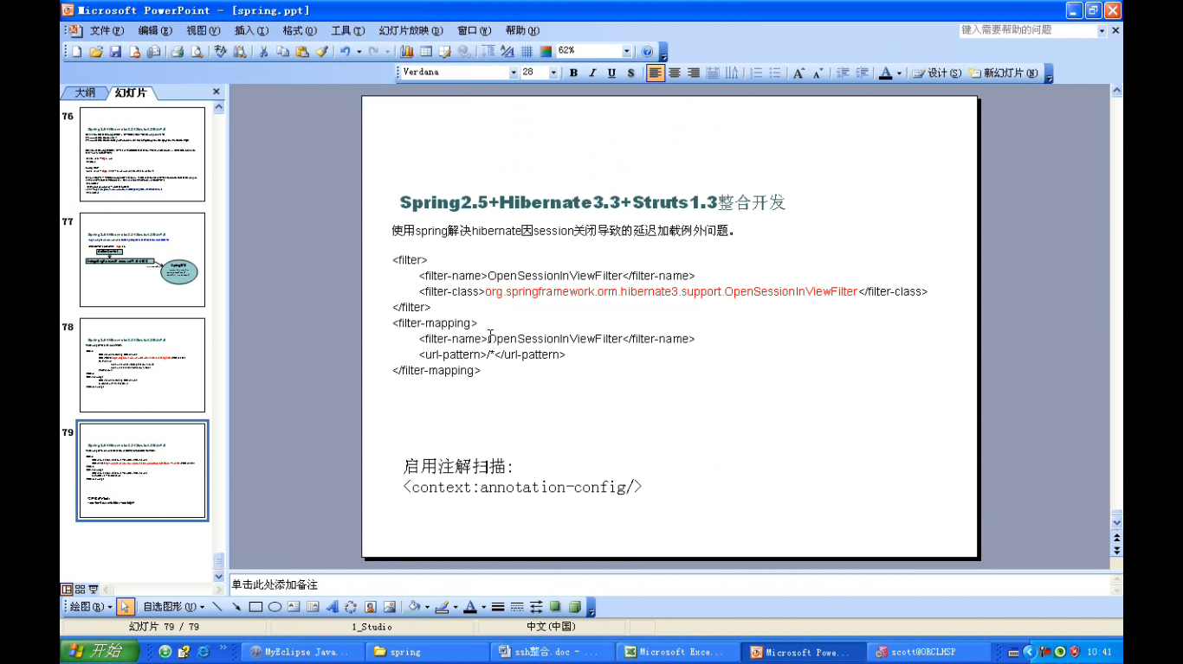

其中过滤器需要在 struts 前面配置

Spring 中提供了一个解决方案来解决懒加载的问题,只需要在WEB.xml 文件中添加一个Filter（过滤器）
<!-- 解决懒加载 -->
<filter>
<filter-name>OpenSessionInViewFilte</filter-name>
<filter-class>org.springframework.orm.hibernate3.support.OpenSessionInViewFilter</filter-class>
</filter>
<filter-mapping>
<filter-name>OpenSessionInViewFilte</filter-name>
<url-pattern>/*</url-pattern>
</filter-mapping>

制定初始化的值
<!-- 解决懒加载 -->
<filter>
<filter-name>OpenSessionInViewFilte</filter-name>
<filter-class>org.springframework.orm.hibernate3.support.OpenSessionInViewFilter</filter-class>
<init-param>
<param-name>sessionFactoryBeanName</param-name>
<param-value>sessionFacotry</param-value>
</init-param>
</filter>
<filter-mapping>
<filter-name>OpenSessionInViewFilte</filter-name>
<url-pattern>/*</url-pattern>
</filter-mapping>

